**Steps to connect to VPN**

Step 1: Go to Cisco AnyConnect

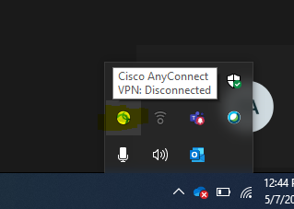

Step 2: Type anyone address and connect - <inmumvpn.tcs.com>, <inmumvpn1.tcs.com> ,<inmumvpn2.tcs.com>

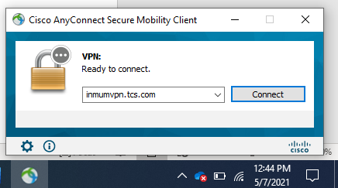

Step 3: Login with your Emp id

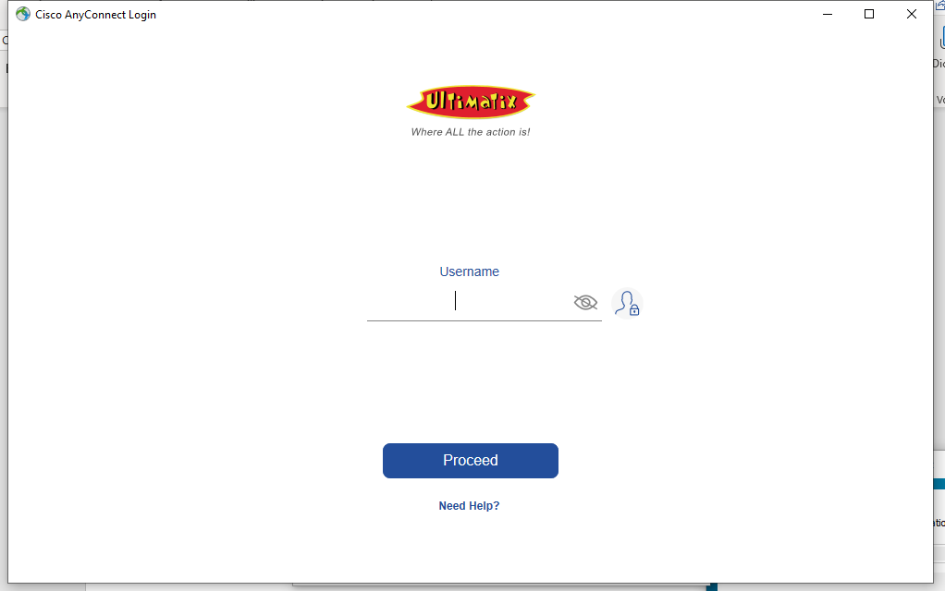

Step 4: Accept the Terms.

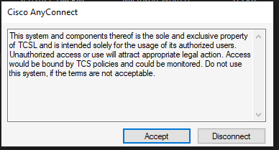

**Finally Connected.**

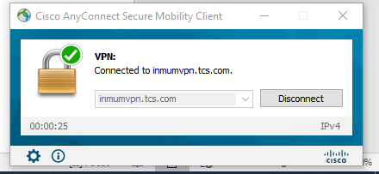

**Troubleshooting the below error**

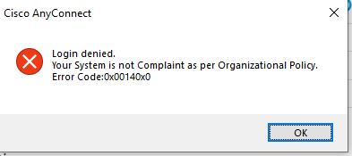

Download TCS SBWS Utility from the given link. <https://uxapps.ultimatix.net/#!/utility>

Step 1: Go to Utilities.

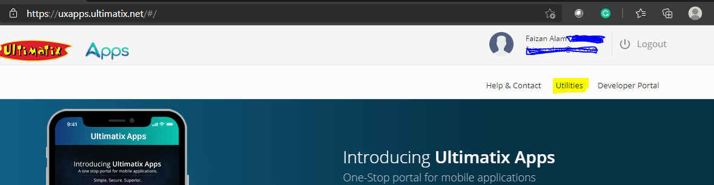

Step 2: Click on Windows System (Non-EU Geos) and download the latest version.

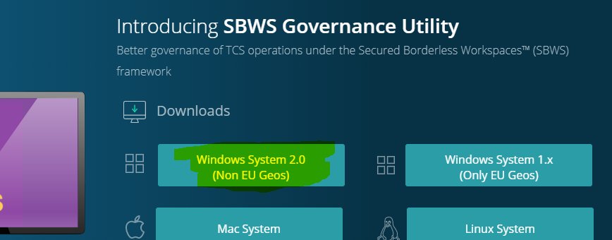

Step 3: Double click and open and fill the details (if details already filled than minimize the TCS sbws)



After Troubleshooting Repeat the 4 Steps to connect to VPN